FACEBOOK ADS PRACTICE CAMPAIGN REPORT
Project Title
Prepared By: Prashant Upadhyay
Internship: Digital Marketing Internship
Project: E-Learning Website Auditing and Digital Marketing Implementation
Date:
Introduction
Facebook advertising is an important part of digital marketing that allows businesses to promote their products and services to specific audiences. Meta Ads Manager provides tools for creating advertisements, selecting target audiences, managing budgets, and monitoring campaign performance.
As part of my digital marketing internship project, I created a practice Facebook Ads campaign for an e-learning website. The campaign was designed to promote the website's Digital Marketing Course and reach potential learners through Facebook and Instagram.
The purpose of this practice campaign was to understand the complete process of planning and setting up a social media advertising campaign, including audience selection, ad creation, budgeting, landing page selection, analytics, and reporting.
Business Introduction
The business used for this practice campaign is an e-learning website that provides online learning opportunities for students, beginners, job seekers, and working professionals.
The platform offers courses in areas such as Digital Marketing, Web Development, Programming, Graphic Design, Data Science, and Business & Finance.
The website is designed to provide flexible and accessible learning resources. Users can explore courses, learn about instructors, read educational blogs, and access different website sections through a simple and user-friendly interface.
For this Facebook Ads practice campaign, the Digital Marketing Course was selected as the main service to promote.
Campaign Objective
The main objective of the practice campaign was to promote the Digital Marketing Course and attract potential learners to the e-learning website.
The campaign was planned with the following objectives:
- Increase awareness of the e-learning platform.
- Promote the Digital Marketing Course.
- Reach people interested in digital marketing and online education.
- Generate potential website visitors and leads.
- Encourage users to explore the available courses.
- Understand the process of creating and managing Facebook Ads.
Campaign Details
Campaign Element | Details
Business | E-Learning Website
Platform | Facebook/Instagram through Meta Ads Manager
Campaign Name | E-Learning – Digital Marketing Course
Campaign Type | Practice Campaign
Objective | Leads
Location | India
Age Group | 18–35
Gender | All
Ad Format | Single Image
Call-to-Action | Learn More
Proposed Daily Budget | ₹500
Landing Page | Digital Marketing Course Page
Campaign Status | Practice / Not Published
The campaign settings above were created for learning and demonstration purposes.
Target Audience
The target audience was selected based on the type of users who may be interested in online digital marketing education.

Target Audience
Location: India
Age: 18–35 years
Gender: All

Potential Audience
- College students
- Fresh graduates
- Job seekers
- Beginners interested in digital marketing
- Working professionals
- People interested in online education

Detailed Interests
Potential interests for the campaign included:
- Digital Marketing
- Online Education
- Search Engine Optimization
- Social Media Marketing
- Google Ads
- E-commerce
- Content Marketing
The audience was designed to be relevant to the Digital Marketing Course and the overall purpose of the e-learning platform.
Campaign Structure

The Facebook Ads campaign was organized into three main levels:

Campaign
E-Learning – Digital Marketing Course
The campaign level defines the overall advertising objective.

Ad Set
India | Age 18–35 | Digital Marketing Interests
The Ad Set level controls the target audience, budget, schedule, and placements.

Ad
Learn Digital Marketing Online
The Ad level contains the advertisement creative, text, headline, call-to-action, and destination URL.

Campaign Flow
Campaign → Ad Set → Ad
This structure helped organize the campaign and separate the overall objective from audience targeting and advertisement content.

Campaign Setup in Meta Ads Manager
The campaign was planned and configured using Meta Ads Manager.
The main setup process included:
Opening Meta Ads Manager
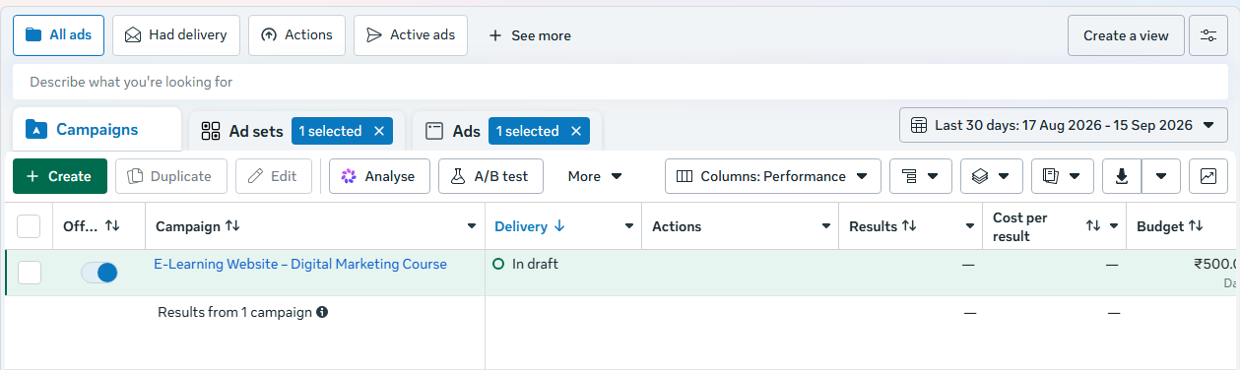
Creating a new campaign
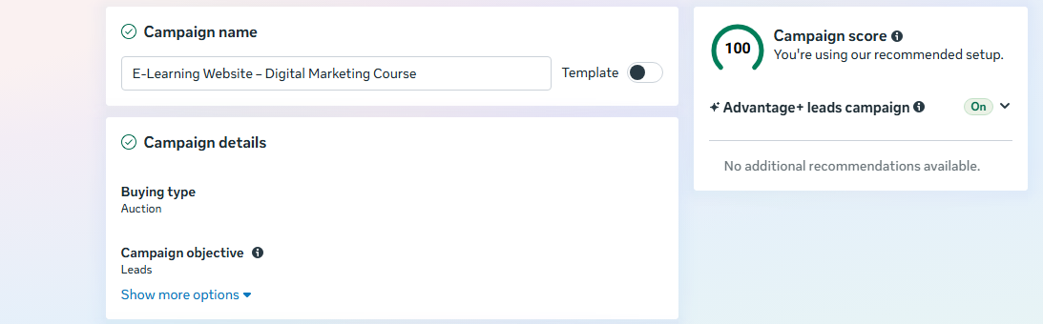
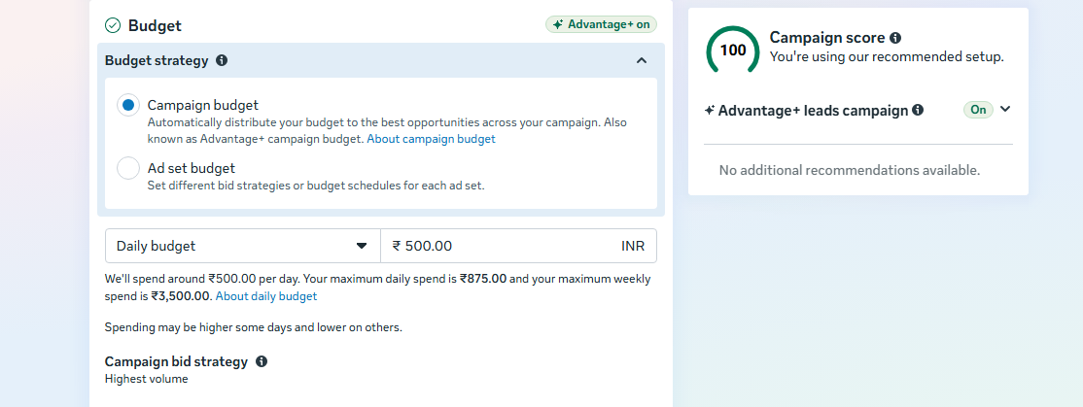
Selecting the campaign objective

Entering the campaign name
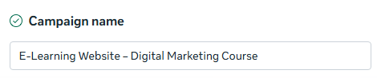
Creating the target audience
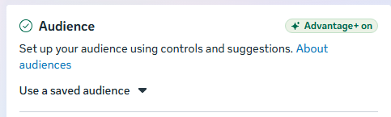
Setting the proposed budget
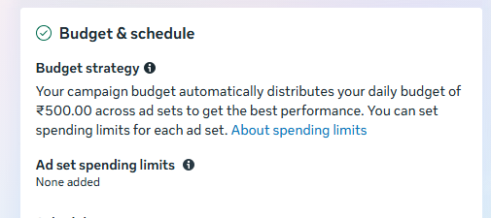
Selecting placements
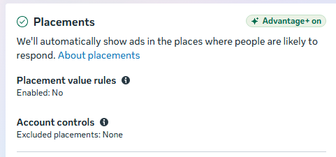

Creating the advertisement

Adding the advertisement text and headline
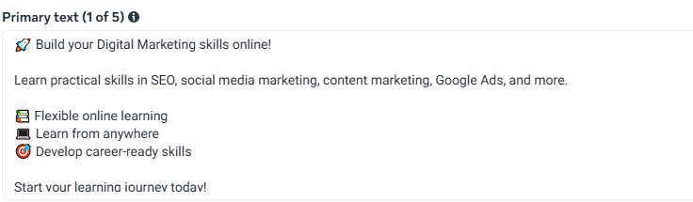

Selecting the call-to-action
Adding the landing page URL


Reviewing the campaign before publishing
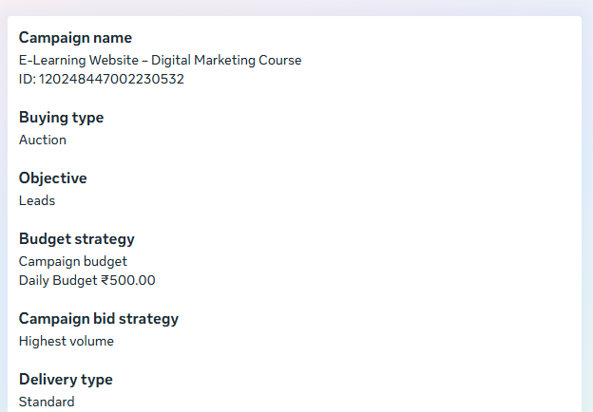
Budget and Schedule
For practice purposes, a proposed daily advertising budget of ₹500 was selected.
The budget was used as an example to understand how campaign spending can be planned and managed.
Proposed Daily Budget: ₹500
Campaign Type: Practice Campaign
Actual Advertising Spend: ₹0, if the campaign was not published.
The campaign schedule can be adjusted according to the business requirements and advertising objectives.
Ad Creative
A promotional image was created using Canva for the Facebook Ads practice campaign.
The advertisement was designed to communicate the main benefits of the Digital Marketing Course in a simple and visually attractive format.

Main Advertisement Text
LEARN DIGITAL MARKETING ONLINE
📚 Practical Courses
💻 Learn Online
🎯 Career-Focused Skills
EXPLORE COURSES
The creative was designed to attract attention and communicate the course benefits quickly.
Ad Copy
The following advertisement copy was prepared for the campaign.

Primary Text
Build your Digital Marketing skills online!
Learn practical skills in SEO, social media marketing, content marketing, Google Ads, and more.
Learn from anywhere and develop career-focused digital marketing skills.
Start your learning journey today!

Headline
Learn Digital Marketing Online

Call-to-Action
Learn More

Destination
The advertisement was designed to direct users to the Digital Marketing Course page on the e-learning website.
Landing Page
The landing page selected for the advertisement was the Digital Marketing Course page.
The purpose of using a relevant course page was to provide users with information about the course immediately after clicking the advertisement.

User Journey
Facebook/Instagram Advertisement
↓
Digital Marketing Course Page
↓
Course Information
↓
Registration / Enrollment
Using a relevant landing page can provide a clear connection between the advertisement and the information presented to the user.
Ad Placements
Meta Ads provides different locations where advertisements can appear across its platforms.
For this practice campaign, the recommended placement settings in Meta Ads Manager were considered.
Potential placements include:
- Facebook Feed
- Instagram Feed
- Instagram Stories
- Facebook Stories
- Other eligible Meta placements
The actual available placements depend on the campaign objective, account configuration, and Meta's current advertising options.
Analytics and Key Performance Indicators
Analytics is an important part of digital advertising because it helps measure how users interact with an advertisement.
The following metrics were identified as important KPIs for this campaign:
Metric | Description
Reach | Number of unique people who saw the advertisement
Impressions | Total number of times the advertisement was displayed
Link Clicks | Number of clicks on the website link
CTR | Percentage of impressions that resulted in clicks
CPC | Average cost for each link click
Leads | Number of potential customers generated
Conversions | Number of users who completed the desired action
Cost per Lead | Average advertising cost for each lead
Since this was a practice campaign, actual performance results were not claimed.
If the campaign is launched in the future, these metrics can be monitored through Meta Ads Manager.
Campaign Reporting
Campaign reporting helps summarize the advertising setup and evaluate performance.
For an actual campaign, the report could include:
- Campaign reach
- Impressions
- Link clicks
- CTR
- CPC
- Leads
- Conversions
- Cost per result
For this practice campaign, the report focuses on the planned campaign structure and measurement framework rather than actual advertising results.

Campaign Summary
Category | Details
Business | E-Learning Website
Product Promoted | Digital Marketing Course
Platform | Meta Ads
Objective | Leads
Audience | Students, beginners, job seekers and professionals
Location | India
Age | 18–35
Ad Format | Single Image
CTA | Learn More
Proposed Budget | ₹500/day
Landing Page | Digital Marketing Course
Status | Practice Campaign

Expected Outcomes
The practice campaign was designed with the following expected outcomes:
- Increase awareness of the e-learning website.
- Promote the Digital Marketing Course.
- Reach users interested in digital marketing.
- Generate website traffic.
- Encourage potential learners to explore the course.
- Generate potential leads if the campaign is launched.
- Develop practical knowledge of Meta Ads Manager.
These are expected outcomes and should not be presented as actual campaign results unless the campaign was launched and generated measurable data.
Challenges Faced
During the practice campaign setup, several areas required attention:
- Understanding the different levels of Meta Ads Manager.
- Selecting a suitable campaign objective.
- Defining a relevant target audience.
- Creating an attractive advertisement creative.
- Writing concise and relevant ad copy.
- Selecting an appropriate landing page.
- Understanding advertising metrics and reporting.
- Learning how campaign budgets and placements work.
These challenges helped improve my practical understanding of social media advertising.
Learning Outcomes
Through this Facebook Ads practice campaign, I learned:
- How Meta Ads Manager is structured.
- How to create an advertising campaign.
- How to select a campaign objective.
- How to define a target audience.
- How to plan a campaign budget.
- How to create an advertisement.
- How to write Facebook ad copy.
- How to select a call-to-action.
- How to connect an advertisement with a landing page.
- How to identify important advertising KPIs.
- How to organize campaign information into a report.
This practical activity helped me understand the role of paid social media advertising in digital marketing.
Conclusion
The Facebook Ads Practice Campaign provided practical experience in planning and setting up a social media advertising campaign for an e-learning website. The campaign focused on promoting a Digital Marketing Course to a relevant audience through Meta Ads Manager.
The project covered important areas including campaign objectives, audience targeting, budgeting, ad creative, ad copy, landing pages, analytics, and reporting.
Although the campaign was created as a practice project, it provided a practical understanding of the steps involved in developing and managing a Facebook advertising campaign. The knowledge gained from this activity can be applied to future digital marketing campaigns and real-world advertising projects.

